**TOPOLOGI JARINGAN**

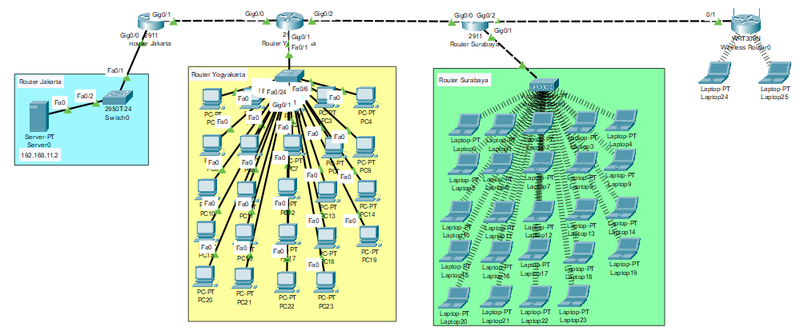

**KONFIG ROUTER JAKARTA**

|  |
| --- |
| Router>en  Router#conf t  Router(config)#int gig0/0  Router(config-if)#ip add 192.168.11.1 255.255.255.224  Router(config-if)#no sh  Router(config)#int gig0/1  Router(config-if)#ip add 192.168.11.33 255.255.255.224  Router(config-if)#no sh  Router(config-if)#router rip  Router(config-if)#network 192.168.11.1  Router(config-if)#network 192.168.11.33 |

**KONFIG ROUTER YOGYAKARTA**

|  |
| --- |
| Router>en  Router#conf t  Router(config)#int gig0/0  Router(config-if)#ip add 192.168.11.34 255.255.255.224  Router(config-if)#no sh  Router(config)#int gig0/1  Router(config-if)#ip add 192.168.11.65 255.255.255.224  Router(config-if)#no sh  Router(config-if)#router rip  Router(config-router)#network 192.168.11.34  Router(config-router)#network 192.168.11.65  Router(config-if)#int gig0/2  Router(config-if)#ip add 192.168.11.97 255.255.255.224  Router(config-if)#no sh |

**KONFIG ROUTER SURABAYA**

|  |
| --- |
| Router>en  Router#conf t  Router(config)#int gig0/0  Router(config-if)#ip add 192.168.11.98 255.255.255.224  Router(config-if)#no sh  Router(config-if)#int gig0/1  Router(config-if)#ip add 192.168.11.129 255.255.255.224  Router(config-if)#no sh  Router(config-if)#router rip  Router(config-router)#network 192.168.11.98  Router(config-router)#network 192.168.11.129 |

**KONFIG WEBSERVER, DATABASE SERVER DAN DNS SERVER**

Web Server

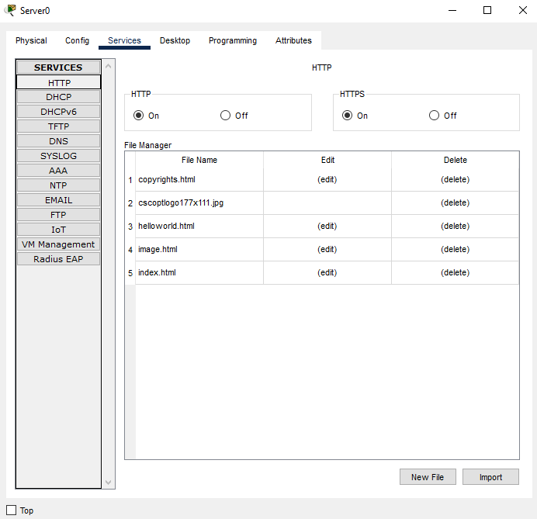

DNS

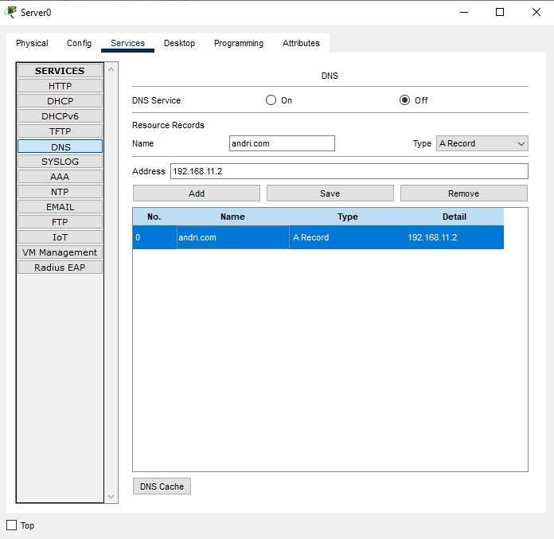

**KONFIG ACCESSPOINT**

Isi dengan Konfigurasi Access Point

**PENGUJIAN KONFIG ROUTING OSPF**

router>enable

router#configure terminal

router(config)# hostname RouterYogyakarta

router(config)#ip dhcp pool RouterYogyakarta

router(dhcp-config)#network 192.168.10.32 255.255.255.224

router(dhcp-config)#default-router 192.168.10.33

router(dhcp-config)#dns-server 8.8.8.8

router(dhcp-config)#exit

router(config)#exit

router#copy running-config startup-config

Destination filename [startup-config]?

Building configuration...

[OK]

router#

**PENGUJIAN AKSES SERVER DARI LAN YOGYAKARTA**

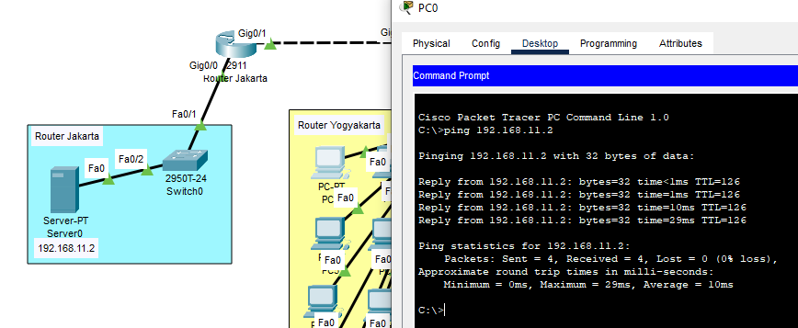

**PENGUJIAN AKSES SERVER DARI LAN SURABAYA**

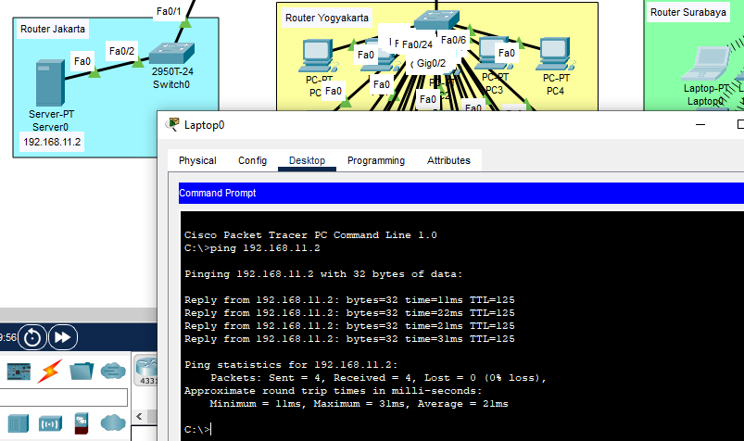

**TABEL IP ADDRESS**

|  |  |  |  |  |  |  |
| --- | --- | --- | --- | --- | --- | --- |
| **Nama Perangkat** | **IP Address** | **Gig0/0** | **Gig0/1** | **Gig0/2** | **Subnet Mask** | **DNS Server** |
| Server | 192.168.11.2 | - | - | - | 255.255.255.224 | 192.168.11.2 |
| Router Jakarta | - | 192.168.11.1 | 192.168.11.33 | - | 255.255.255.224 | - |
| Router Yogyakarta | - | 192.168.11.34 | 192.168.11.65 | 192.168.11.97 | 255.255.255.224 | - |
| Router Surabaya | - | 192.168.11.98 | 192.168.11.129 | 192.168.11.161 | 255.255.255.224 | - |
| Wireless Router | 192.168.11.167 | - | - | - | 255.255.255.224 | 192.168.11.2 |
| PC0 - PC23 | 192.168.11.66-192.168.11.89 | - | - | - | 255.255.255.224 | 192.168.11.2 |
| Laptop0 – Laptop1 | 192.168.11.131-192.168.11.154 | - | - | - | 255.255.255.224 | 192.168.11.2 |
| Laptop24 | 192.168.11.169 | - | - | - | 255.255.255.224 | 192.168.11.2 |
| Laptop25 | 192.168.11.170 | - | - | - | 255.255.255.224 | 192.168.11.2 |

**SPESIFIKASI PERANGKAT**

Hardware:

* Proccessor i5 gen7
* RAM 8GB
* SSD 240GB

Software:

* Cisco Packet Tracer